CI/CD Pipeline For WebApplication Using AWS

INTRODUCTION
VENKADESH.V
Class Time: 3.30pm to 5.00pm
Joining date: 20/02/2026

The CI/CD Pipeline for Web Application using AWS is a DevOps project developed to automate the process of building, testing, and deploying a web application. The project integrates Git, GitHub, Jenkins, Docker, Python Flask, and AWS EC2 to create an efficient automated deployment workflow. Whenever new code is pushed to GitHub, a webhook automatically triggers Jenkins to execute the pipeline. Jenkins tests the application, builds a Docker image, deploys the application as a container, and verifies its health. This project demonstrates how CI/CD automation can reduce manual effort, improve deployment speed, and provide reliable application delivery.

OBJECTIVES

- To automate the application deployment process using CI/CD practices.
- To integrate Git, GitHub, Jenkins, and Docker into a single automated workflow.
- To automatically build, test, and deploy the Flask web application whenever new code is pushed to GitHub.
- To use AWS EC2 as the cloud environment for hosting Jenkins and the Dockerized application.
- To reduce manual effort and improve deployment speed, consistency, and reliability.
TECHNOLOGIES USED

- AWS EC2 – Hosts the entire project
- Ubuntu - Operating system
- Git - Version control
- GitHub - Source code repository
- Jenkins - CI/CD automation
- Docker - Application containerization
- Flask - Web application
- GitHub Webhook - Automatically triggers Jenkins

ARCHITECTURE DIAGRAM

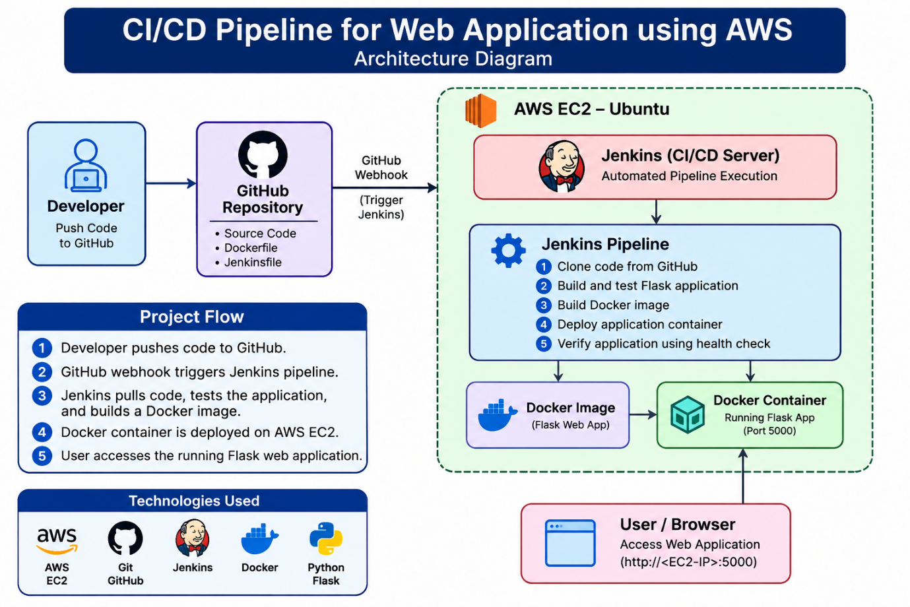
IMPLEMENTATION

AWS EC2 Setup
Open the AWS console and launch the new instance and named it, the connect it to the terminal.
The required Security Group rules were configured to allow:
- SSH Access (Port 22)
- Flask Application (Port 5000)
- Jenkins (Port 8080)
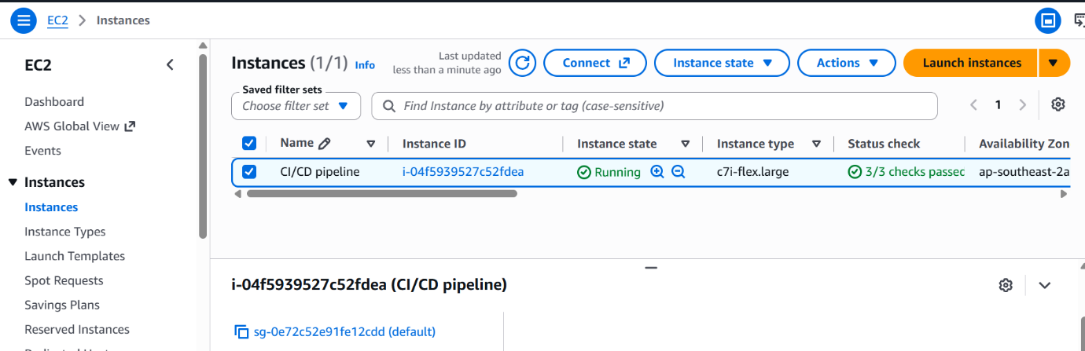
- HTTP (Port 80)

Update the Ubuntu package using the command
- sudo apt update
- sudo apt upgrade -y
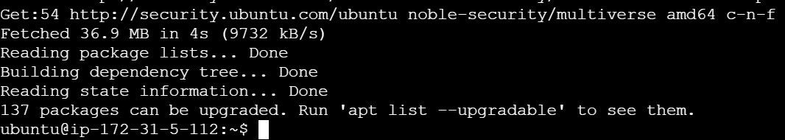
Install Git & Docker

Install the git , because it tracks changes in our application source code.
- sudo apt install git -y
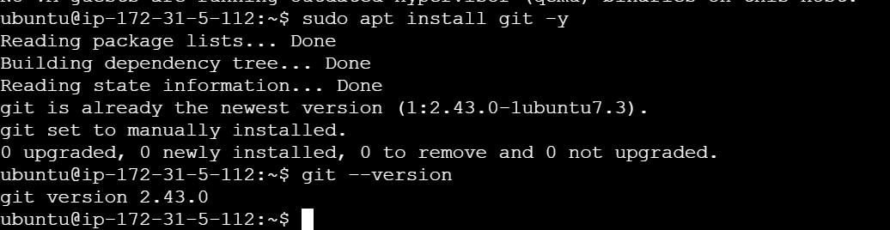
- git --version

Install the docker because, Docker packages the Flask application and its dependencies into a container.
- sudo apt install docker.io -y
- sudo systemctl start docker
- sudo systemctl enable docker
- sudo systemctl status docker
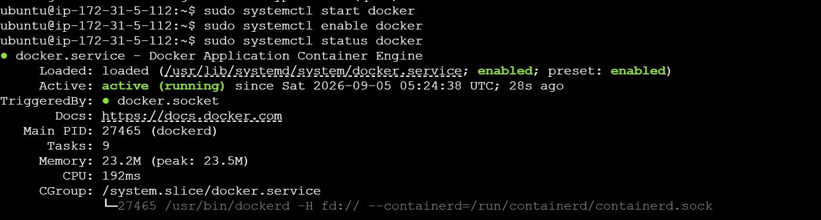
Allow ubuntu user to run the docker without sudo.
- sudo usermod -aG docker ubuntu
- newgrp docker
Now we checking without the sudo
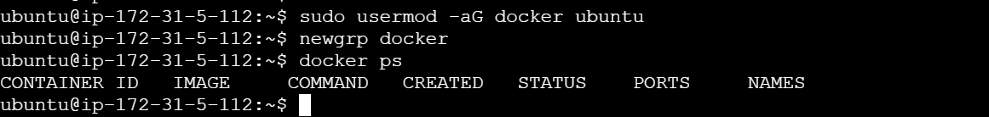
- docker ps

Create Web Application & Dockerfile

Create the project folder:
- mkdir project
Enter the directory
- Cd project
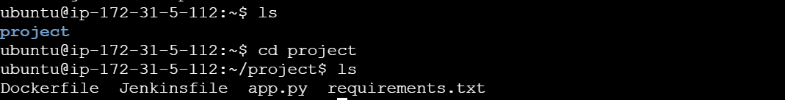

Now Build the docker image using
- docker build -t devops-webapp .
- docker images
now we can see the output
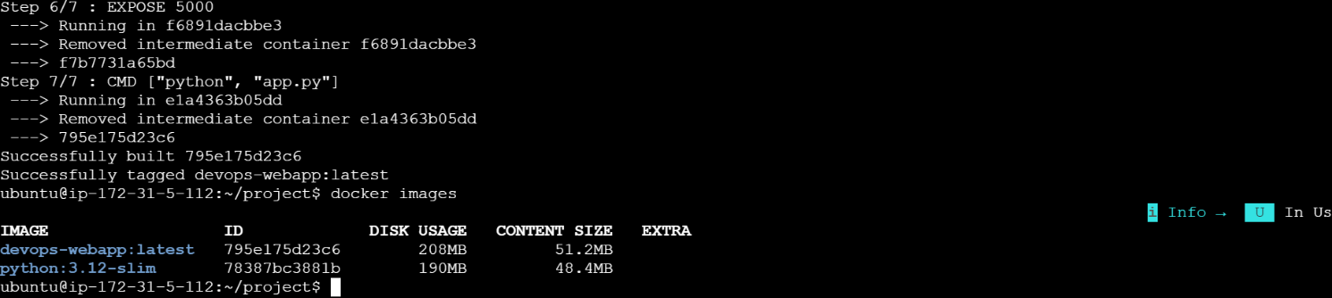
Now Run the container using
- docker run -d --name devops-webapp -p 5000:5000 devops-webapp
- docker ps

Now test the application In terminal using
- curl http://localhost:5000
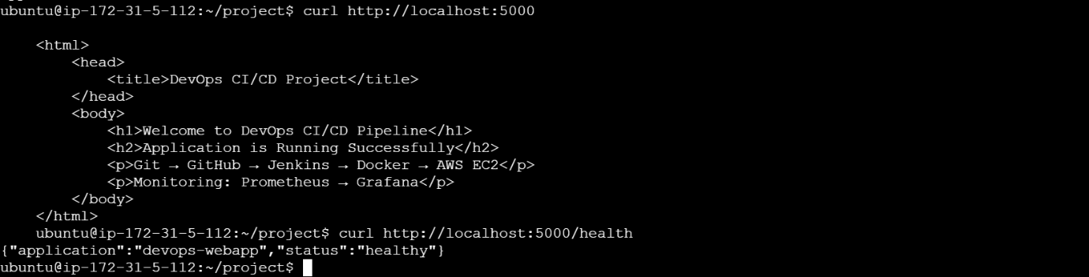
- curl http://localhost:5000/health

Now open the web browser using your EC2 public ip to see the application dashboard
- http:// YOUR_EC2_PUBLIC_IP
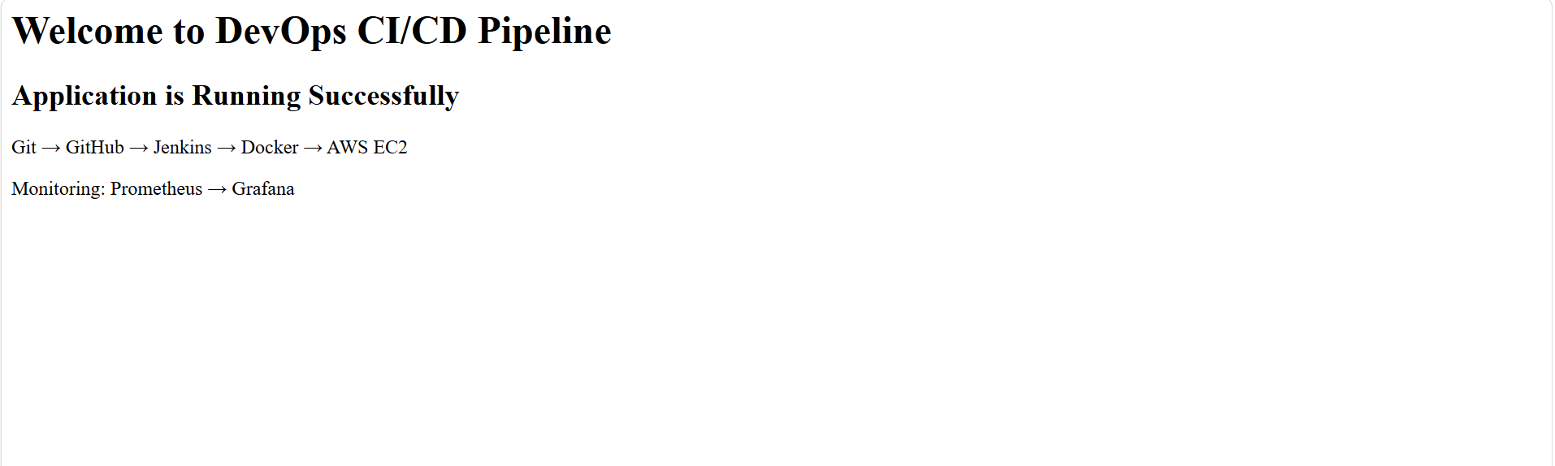
Push the project to Github

Configure Git on EC2
- git config --global user.name "username"
- git config --global user.email "YOUR_GITHUB_EMAIL"
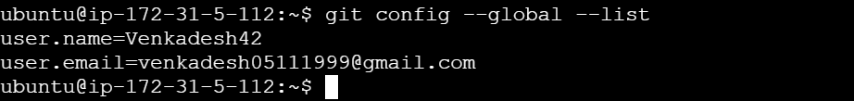
- git config --global –list

Initiate the git
- git init
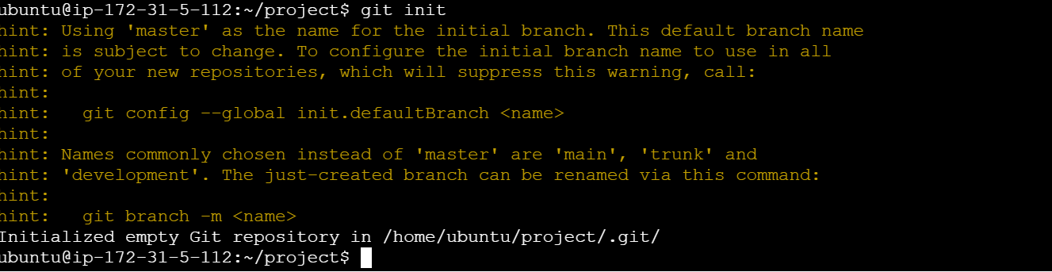

- git add .
- git status
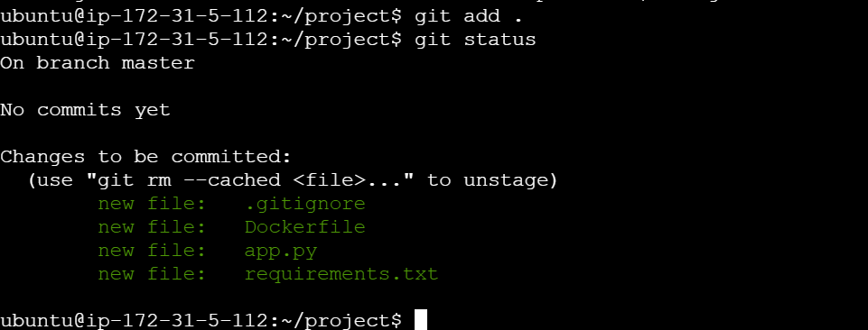

Now create a github repository to store code
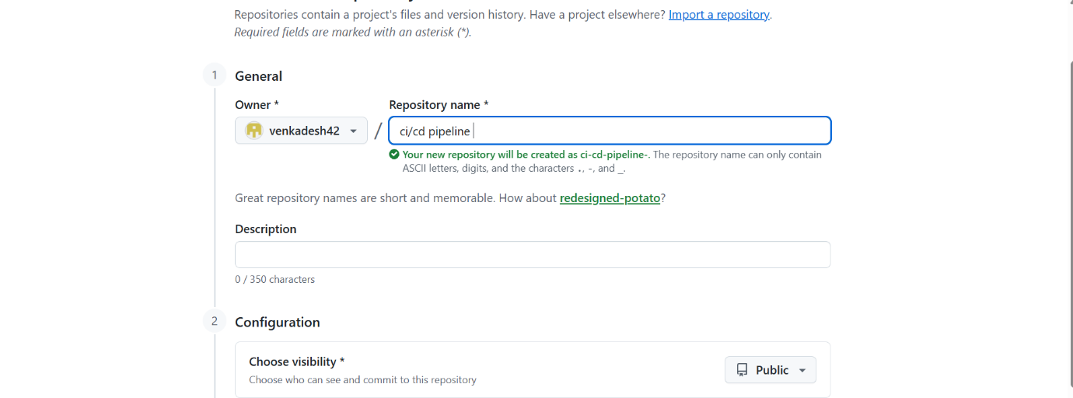

Now ready to push the code to repository
- git commit -m "comment"
- git branch -M main
- git remote add origin https://github.com/YOUR_USERNAME/devops-cicd-project.git
- git push -u origin main
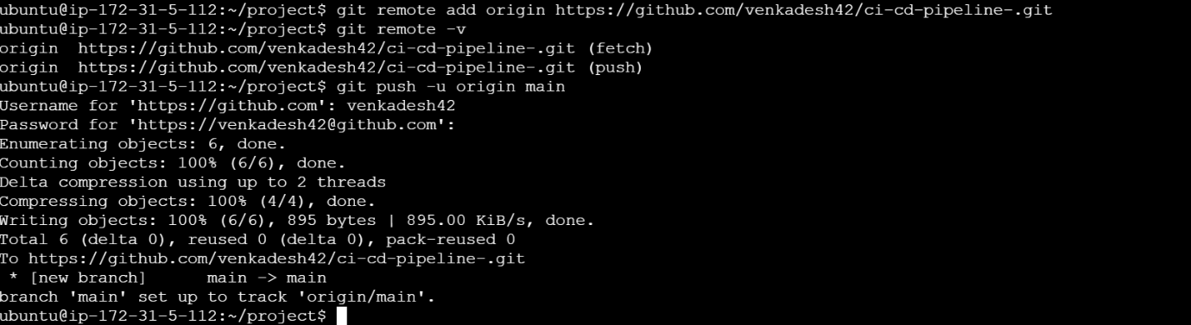


now we can see the files are moved to guthub
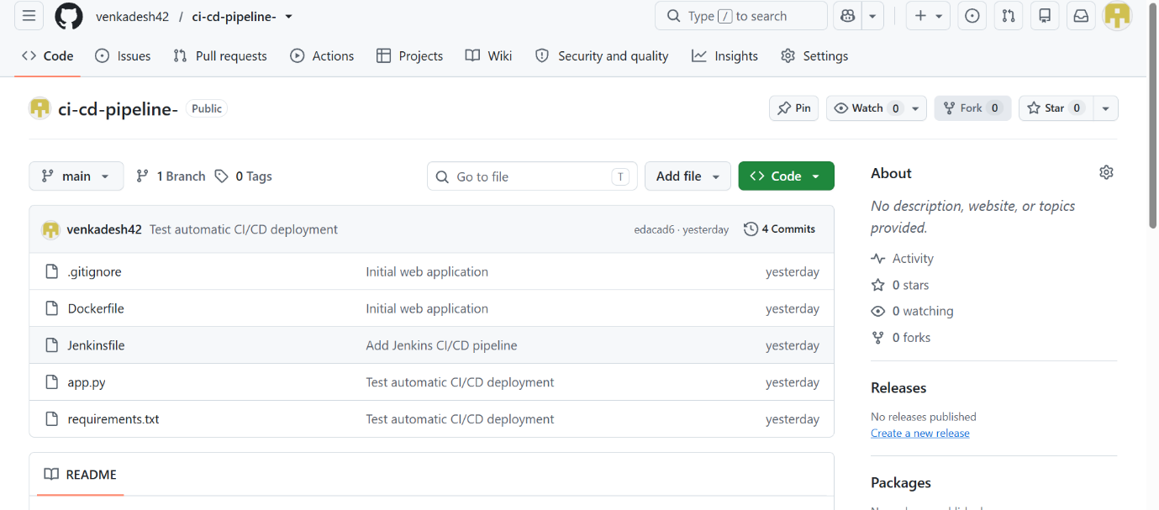

Install Jenkins

Install Jenkins using the commands also java,Jenkins repository
- sudo apt install fontconfig openjdk-21-jre -y
- sudo mkdir -p /etc/apt/keyrings
- sudo wget -O /etc/apt/keyrings/jenkins-keyring.asc \
- https://pkg.jenkins.io/debian-stable/jenkins.io-2026.key
- echo "deb [signed-by=/etc/apt/keyrings/jenkins-keyring.asc] https://pkg.jenkins.io/debian-stable binary/" | sudo tee /etc/apt/sources.list.d/jenkins.list > /dev/null
- sudo apt install jenkins -y
- sudo systemctl enable jenkins
- sudo systemctl start Jenkins
- sudo systemctl status Jenkins
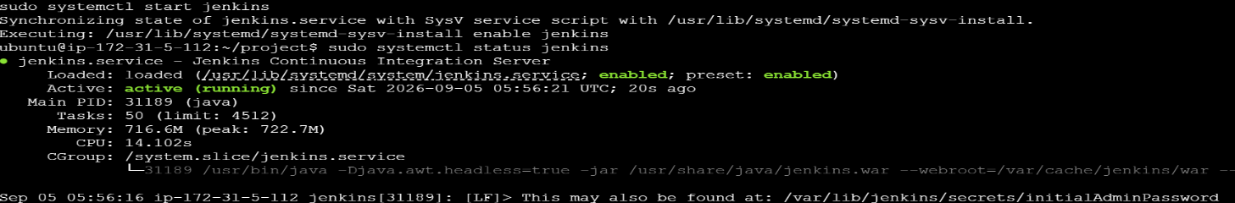

- sudo cat /var/lib/jenkins/secrets/initialAdminPassword
use this command to get a password to login Jenkins.

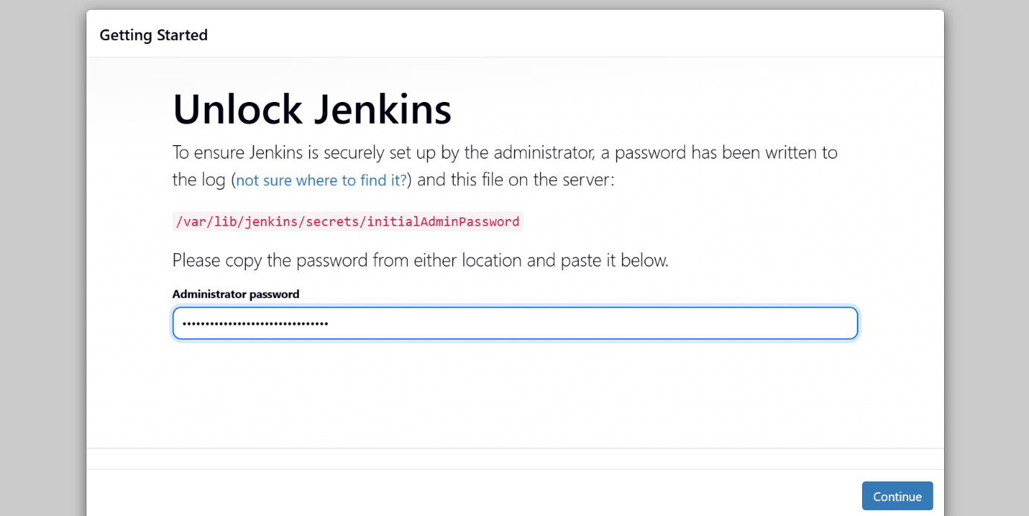

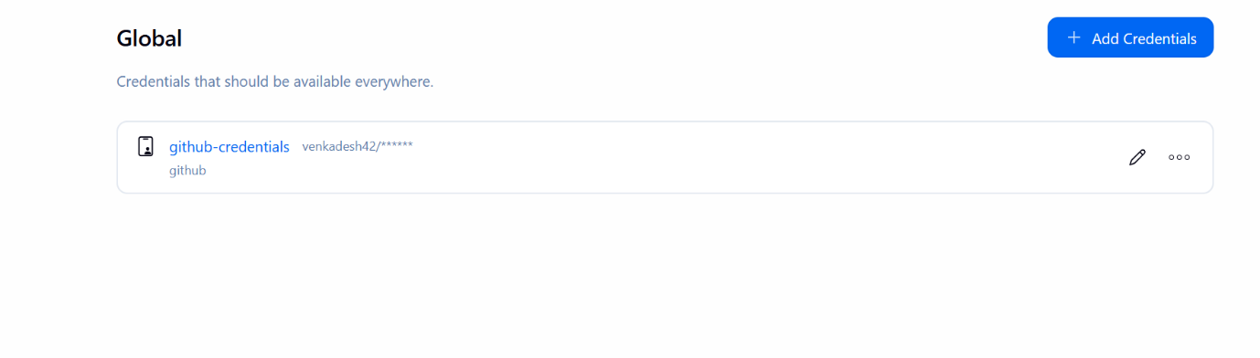
We give GitHub credentials to Jenkins so Jenkins can access the GitHub repository securely.

Create a new job and give name and select git under the scm and select the credentials then click save.

Then click the build now to see the process of build,test and deploy.
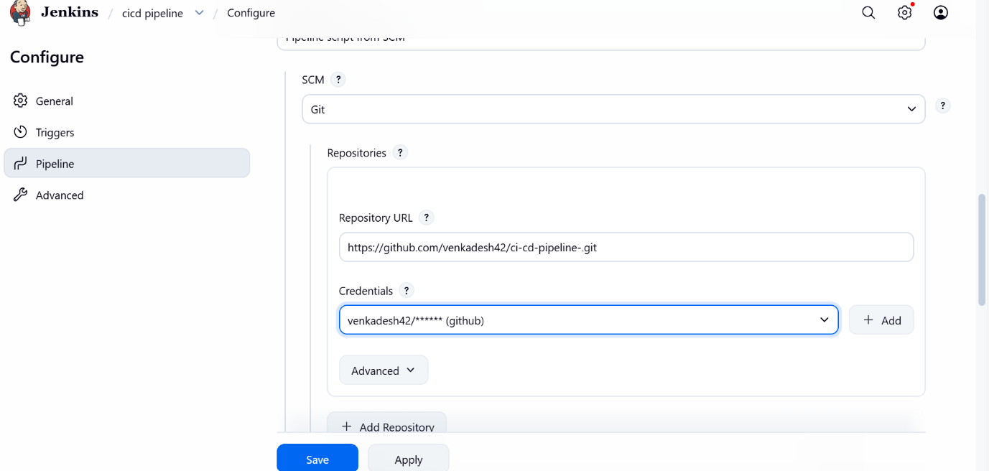

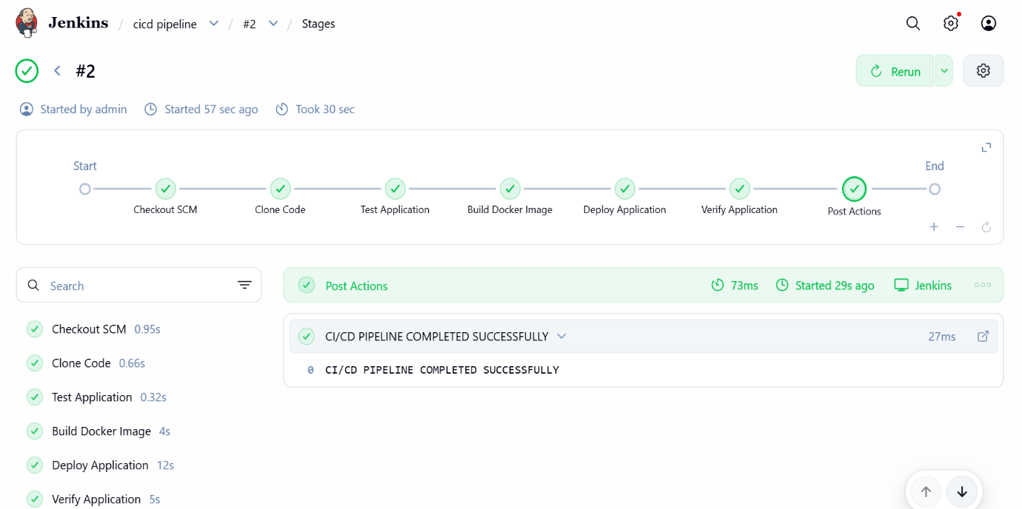

Now check the application using docker ps

Automatic Trigger From Jenkins To Github

Adding github webhook to automaticall trigger and run the test when code is pushed to github.
Find build trigger and enable github webhook in Jenkins.
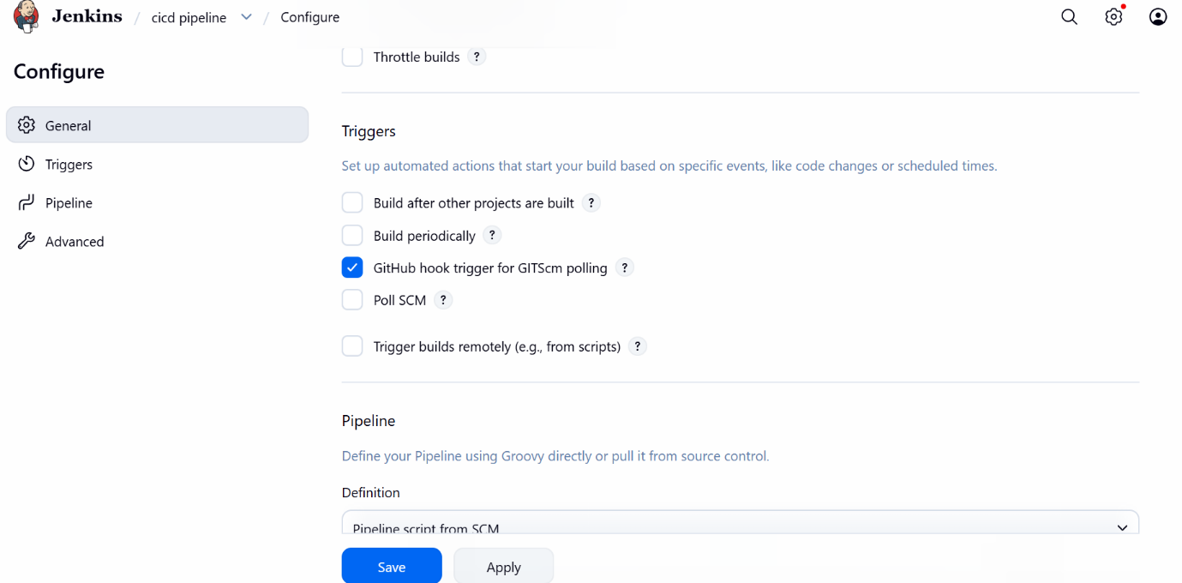

Add this link in webhook to connect Jenkins to automate the testing process .
http://3.25.215.120:8080/github-webhook/

now again we check the process how its work after adding webhook for automate process.
This is the old dashboard.
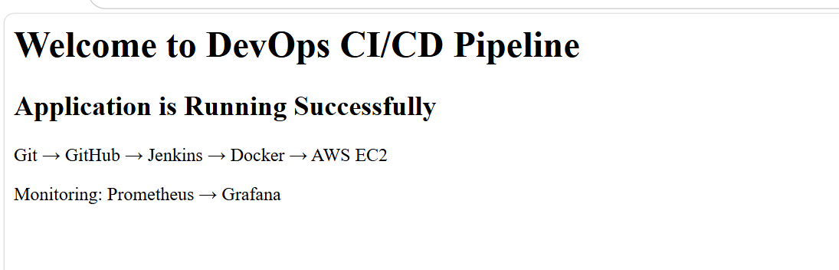
Here you can see application is running successfully in old dashboard.
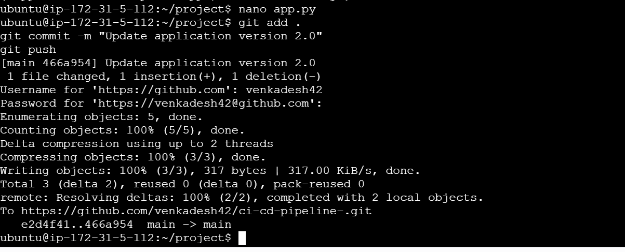
After some change now new code is pushed to github.

After this now Jenkins pipeline build automatically without the manual start because when the new code is pushed so the webhook trigger the Jenkins to start the process.

After this you can see the changes in web dashboard also.
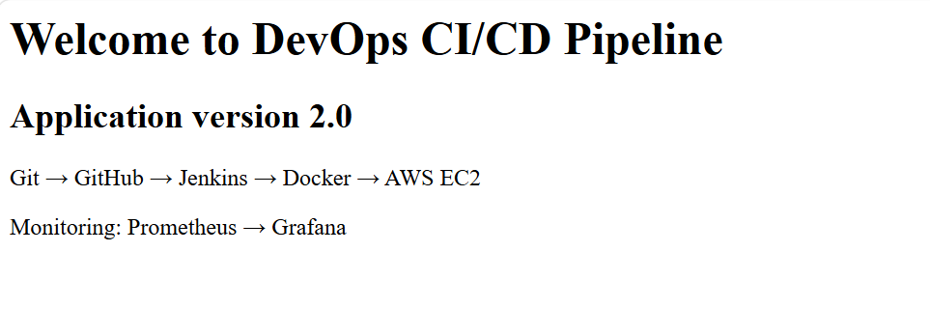
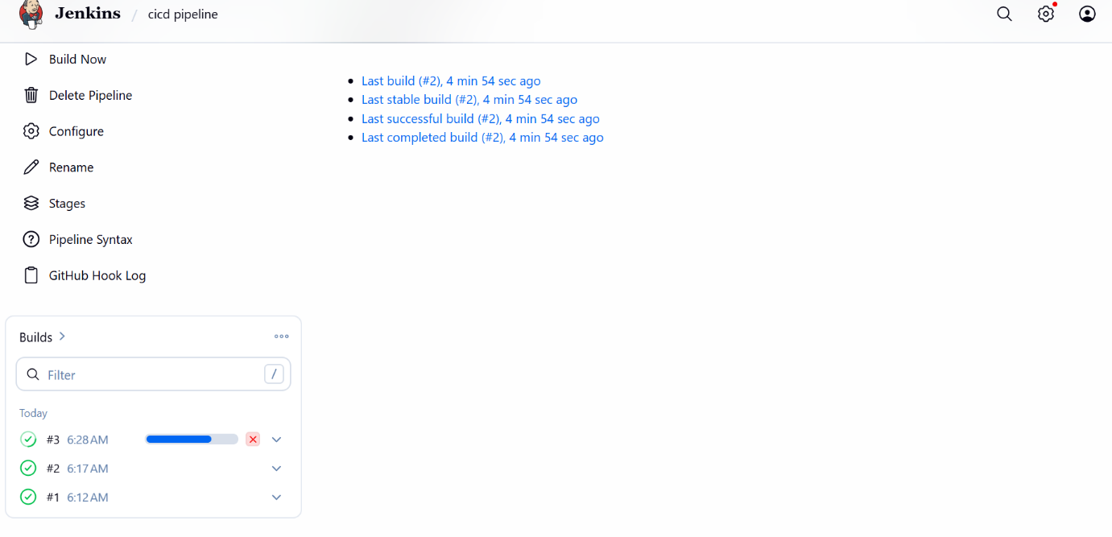

Now you can see the corrections, so the ci/cd pipeline web application is working correctly without manual start using automatically by webhook.

CONCLUSION

The CI/CD Pipeline for Web Application using AWS successfully demonstrates the automation of the software development and deployment process. The integration of GitHub, Jenkins, Docker, and AWS EC2 enables the application to be tested, built, and deployed automatically. The pipeline also performs a health check to ensure that the application is running successfully after deployment. Overall, this project demonstrates how DevOps and CI/CD practices can improve deployment efficiency, reliability, and consistency.

